Prepared for: Shawn Irvine, City of Independence
From: Martin Kraal, Workforce Analyst, (503) 302-8568, Martin.E.Kraal@state.or.us
Date: June 28, 2012

Question: What is the profile of the Independence workforce? What are some general numbers for the workforce within 30 miles of Independence?

The tables below provide workforce information for the Independence area. The government sector employs the largest number of workers in Independence, where the manufacturing sector employs the largest number in the private sector (Table 1). The employment data are for 2010, which is the most recent year available.

Table 1: Employment by Industry in Independence, 2010

Industry (NAICS) | Number of Establishments | Annual Average Employment | Percentage of Total Employment | Annual Average Pay
Total All Ownerships | 238 | 2,254 | - | $ 28,086
Total Private Coverage | 228 | 1,789 | 79% | $ 26,715
Natural Resources & Mining | 22 | 338 | 15% | $ 23,535
Construction | 15 | 32 | 1% | $ 23,548
Manufacturing | 12 | 414 | 18% | $ 37,864
Wholesale Trade | 10 | 27 | 1% | $ 48,649
Retail Trade | 26 | 264 | 12% | $ 23,694
Transportation and Warehousing | 6 | 85 | 4% | $ 31,654
Information | 3 | c | c | c
Financial Activities | 16 | 46 | 2% | $ 21,731
Professional and Technical Services | 14 | 22 | 1% | $ 30,406
Management of Companies and Enterprises | 1 | c | c | c
Administrative and Waste Services | 10 | 39 | 2% | $ 20,405
Educational Services | 3 | c | c | c
Health Care and Social Assistance | 30 | 230 | 10% | $ 26,543
Arts, Entertainment, and Recreation | 5 | c | c | c
Accommodation and Food Services | 16 | 156 | 7% | $ 11,269
Other Services | 39 | 101 | 4% | $ 19,678
Total All Government | 10 | 465 | 21% | $ 33,361

c – Confidential

Source: Oregon Employment Department, Quarterly Census of Employment and Wages.

Table 2: Profile of Workers in Independence

 | 2010
 | Count | Share
Total Primary Jobs | 1,573 | 100.0%
Jobs by Worker Age
Age 29 or younger | 401 | 25.5%
Age 30 to 54 | 866 | 55.1%
Age 55 or older | 306 | 19.5%
Jobs by Earnings
$1,250 per month or less | 427 | 27.1%
$1,251 to $3,333 per month | 770 | 49.0%
More than $3,333 per month | 376 | 23.9%
Jobs by Worker Race
White Alone | 1,479 | 94.0%
Black or African American Alone | 11 | 0.7%
American Indian or Alaska Native Alone | 22 | 1.4%
Asian Alone | 38 | 2.4%
Native Hawaiian or Other Pacific Islander Alone | 4 | 0.3%
Two or More Race Groups | 19 | 1.2%
Jobs by Worker Ethnicity
Not Hispanic or Latino | 1,275 | 81.1%
Hispanic or Latino | 298 | 18.9%
Jobs by Worker Educational Attainment
Less than high school | 165 | 10.5%
High school or equivalent, no college | 360 | 22.9%
Some college or Associate degree | 403 | 25.6%
Bachelor's degree or advanced degree | 244 | 15.5%
Educational attainment not available (workers aged 29 or younger) | 401 | 25.5%
Jobs by Worker Sex
Male | 845 | 53.7%
Female | 728 | 46.3%

Source: U.S. Census Bureau. 2012. OnTheMap Application. Longitudinal-Employer Household Dynamics Program. http://onthemap.ces.census.gov/.

Figure 1: Commuting Patterns in Independence

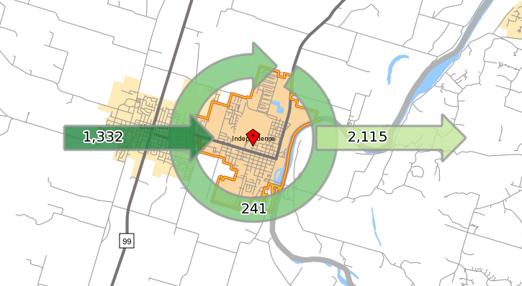
Table 4: Where Workers are Employed Who Live in Independence (by place)

 | 2010
 | Count | Share
Total Primary Jobs | 2,356 | 100.0%
Salem, OR | 596 | 25.3%
Independence, OR | 241 | 10.2%
Monmouth, OR | 203 | 8.6%
Portland, OR | 162 | 6.9%
Corvallis, OR | 117 | 5.0%
Dallas, OR | 115 | 4.9%
Albany, OR | 88 | 3.7%
McMinnville, OR | 36 | 1.5%
Grand Ronde, OR | 35 | 1.5%
Beaverton, OR | 32 | 1.4%
All Other Locations | 731 | 31.0%

Table 3: Where Workers Live Who are Employed in Independence (by place)

 | 2010
 | Count | Share
Total Primary Jobs | 1,573 | 100.0%
Monmouth, OR | 252 | 16.0%
Independence, OR | 241 | 15.3%
Salem, OR | 200 | 12.7%
Dallas, OR | 128 | 8.1%
Albany, OR | 52 | 3.3%
Four Corners CDP, OR | 38 | 2.4%
Keizer, OR | 35 | 2.2%
Hayesville CDP, OR | 29 | 1.8%
Corvallis, OR | 23 | 1.5%
McMinnville, OR | 17 | 1.1%
All Other Locations | 558 | 35.5%

Source: U.S. Census Bureau. 2012. OnTheMap Application. Longitudinal-Employer Household Dynamics Program. http://onthemap.ces.census.gov/.

Workforce within 30 miles of Independence

The following tables provide information about workers within 30 miles of Independence. As shown in the map, this area includes several cities in the Willamette Valley such as Salem, Corvallis, Albany, and McMinnville. The data are from the U.S. Census Bureau’s OnTheMap application.

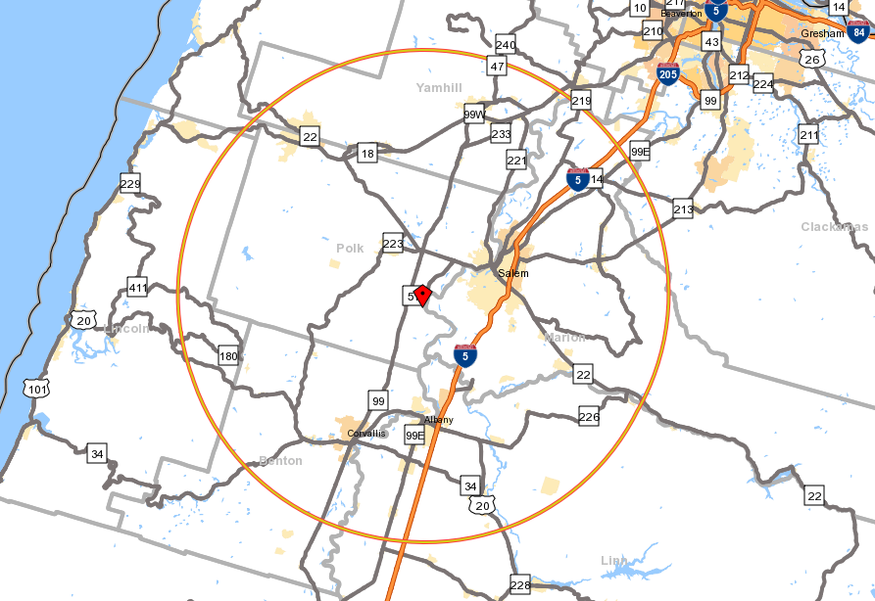

Table 5: Jobs by Industry Sector within 30 miles of Independence

 | 2010
 | Count | Share
Total Primary Jobs | 214,542 | 100.0%
Agriculture, Forestry, Fishing and Hunting | 9,564 | 4.5%
Mining, Quarrying, and Oil and Gas Extraction | 381 | 0.2%
Utilities | 667 | 0.3%
Construction | 10,848 | 5.1%
Manufacturing | 22,255 | 10.4%
Wholesale Trade | 5,549 | 2.6%
Retail Trade | 22,198 | 10.3%
Transportation and Warehousing | 5,665 | 2.6%
Information | 2,580 | 1.2%
Finance and Insurance | 5,826 | 2.7%
Real Estate and Rental and Leasing | 2,755 | 1.3%
Professional, Scientific, and Technical Services | 7,334 | 3.4%
Management of Companies and Enterprises | 2,613 | 1.2%
Administration & Support, Waste Management and Remediation | 8,742 | 4.1%
Educational Services | 25,232 | 11.8%
Health Care and Social Assistance | 31,816 | 14.8%
Arts, Entertainment, and Recreation | 1,688 | 0.8%
Accommodation and Food Services | 15,704 | 7.3%
Other Services (excluding Public Administration) | 7,294 | 3.4%
Public Administration | 25,831 | 12.0%

Table 6: Profile of Workers within 30 miles of Independence

 | 2010
 | Count | Share
Total Primary Jobs | 214,542 | 100.0%
Jobs by Worker Age
Age 29 or younger | 46,947 | 21.9%
Age 30 to 54 | 119,711 | 55.8%
Age 55 or older | 47,884 | 22.3%
Jobs by Earnings
$1,250 per month or less | 47,041 | 21.9%
$1,251 to $3,333 per month | 91,339 | 42.6%
More than $3,333 per month | 76,162 | 35.5%
Jobs by Worker Race
White Alone | 199,472 | 93.0%
Black or African American Alone | 2,447 | 1.1%
American Indian or Alaska Native Alone | 2,715 | 1.3%
Asian Alone | 5,585 | 2.6%
Native Hawaiian or Other Pacific Islander Alone | 630 | 0.3%
Two or More Race Groups | 3,693 | 1.7%

Table 6 continued: Profile of Workers within 30 miles of Independence

 | 2010
 | Count | Share
Jobs by Worker Ethnicity
Not Hispanic or Latino | 192,842 | 89.9%
Hispanic or Latino | 21,700 | 10.1%
Jobs by Worker Educational Attainment
Less than high school | 17,775 | 8.3%
High school or equivalent, no college | 47,861 | 22.3%
Some college or Associate degree | 58,219 | 27.1%
Bachelor's degree or advanced degree | 43,740 | 20.4%
Educational attainment not available (workers aged 29 or younger) | 46,947 | 21.9%
Jobs by Worker Sex
Male | 104,098 | 48.5%
Female | 110,444 | 51.5%

General Population Demographics

These final tables provide demographic information from the U.S. Census Bureau’s American Community Survey (ACS) on the population in Independence. The data are five-year estimates from 2006 to 2010 and reflect the average over the entire period.

Table 7: Educational Attainment in Independence, 2006-2010

 | Estimate | Estimate Margin of Error | Percent | Percent Margin of Error
Population 25 years and over | 4,574 | +/-294 | 4,574 | (X)
Less than 9th grade | 494 | +/-134 | 10.8% | +/-3.0
9th to 12th grade, no diploma | 482 | +/-174 | 10.5% | +/-3.9
High school graduate (includes equivalency) | 1,036 | +/-252 | 22.6% | +/-4.9
Some college, no degree | 1,151 | +/-213 | 25.2% | +/-4.5
Associate's degree | 399 | +/-163 | 8.7% | +/-3.6
Bachelor's degree | 668 | +/-175 | 14.6% | +/-3.7
Graduate or professional degree | 344 | +/-157 | 7.5% | +/-3.3
Percent high school graduate or higher | (X) | (X) | 78.7% | +/-4.1
Percent bachelor's degree or higher | (X) | (X) | 22.1% | +/-5.3

Source: U.S. Census Bureau, 2006-2010 American Community Survey.

Table 8: Housing Units in Independence, 2006-2010

 | Estimate | Estimate Margin of Error | Percent | Percent Margin of Error
Total housing units | 3,166 | +/-233 | (X) | (X)
Occupied housing units | 2,827 | +/-217 | 89.3% | +/-4.5
Owner-occupied | 1,953 | +/-193 | 69.1% | +/-6.8
Renter-occupied | 874 | +/-226 | 30.9% | +/-6.8
Vacant housing units | 339 | +/-151 | 10.7% | +/-4.5
Homeowner vacancy rate | 1.8 | +/-2.9 | (X) | (X)
Rental vacancy rate | 14.1 | +/-10.8 | (X) | (X)
Average household size of owner-occupied unit | 3.00 | +/-0.27 |  | (X)
Average household size of renter-occupied unit | 2.62 | +/-0.33 | (X) | (X)

Source: U.S. Census Bureau, 2006-2010 American Community Survey.

Table 9: Household and Per Capita Income in Independence
 | Estimate | Estimate Margin of Error | Percent | Percent Margin of Error
Total households | 2,827 | +/-217 | 2,827 | (X)
Less than $10,000 | 240 | +/-135 | 8.5% | +/-4.5
$10,000 to $14,999 | 169 | +/-85 | 6.0% | +/-2.8
$15,000 to $24,999 | 292 | +/-128 | 10.3% | +/-4.7
$25,000 to $34,999 | 376 | +/-144 | 13.3% | +/-4.8
$35,000 to $49,999 | 478 | +/-133 | 16.9% | +/-5.0
$50,000 to $74,999 | 538 | +/-159 | 19.0% | +/-5.3
$75,000 to $99,999 | 372 | +/-119 | 13.2% | +/-4.3
$100,000 to $149,999 | 264 | +/-111 | 9.3% | +/-3.9
$150,000 to $199,999 | 73 | +/-87 | 2.6% | +/-3.0
$200,000 or more | 25 | +/-29 | 0.9% | +/-1.0
Median household income (dollars) | $ 46,259 | +/-4,933 | (X) | (X)
Per capita income (dollars) | $ 19,106 | +/-2,417 | (X) | (X)

Source: U.S. Census Bureau, 2006-2010 American Community Survey.

